How CSU-Fullerton increased graduation rates by 11%
California State University—Fullerton
Case Study|November 20, 2015

- About: California State University—Fullerton is a public master’s university with an undergraduate enrollment of 33,000 students and a six-year graduation rate of 62%.
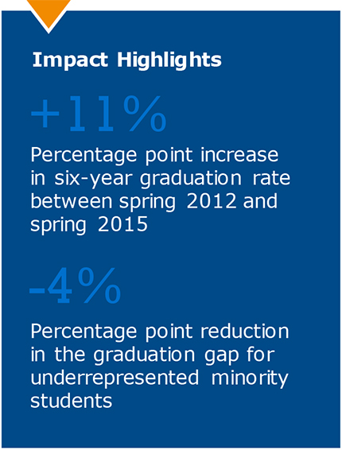
- Challenge: CSU-Fullerton enrolls almost 70% ethnic minorities and 40% students from historically underrepresented groups. Three years ago, graduation rates hovered in the low 50s and the graduation gap was 12%.

- Solution: In 2013, CSU-Fullerton launched a five-year strategic plan with ambitious goals of narrowing the graduation gap for underrepresented minority students by half and raising overall graduation rates to 60%. To accomplish this, Fullerton took an innovative approach that combined infrastructure changes, the addition of a new Graduation Specialist role empowered with a technology toolbox, and a focus on tech-enabled, scalable interventions.

- Impact: CSU-Fullerton exceeded their strategic goals, inflecting graduation rates by 11 percentage points in three years and narrowing the graduation gap by 4 percentage points.

Exceeding Strategic Goals by Rapidly Inflecting Long-Term Student Outcomes
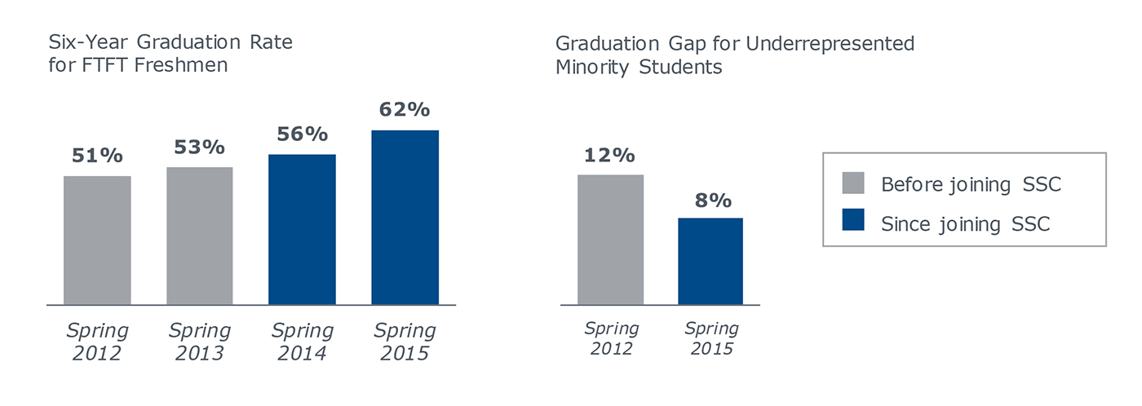

Building a New Student Success Infrastructure
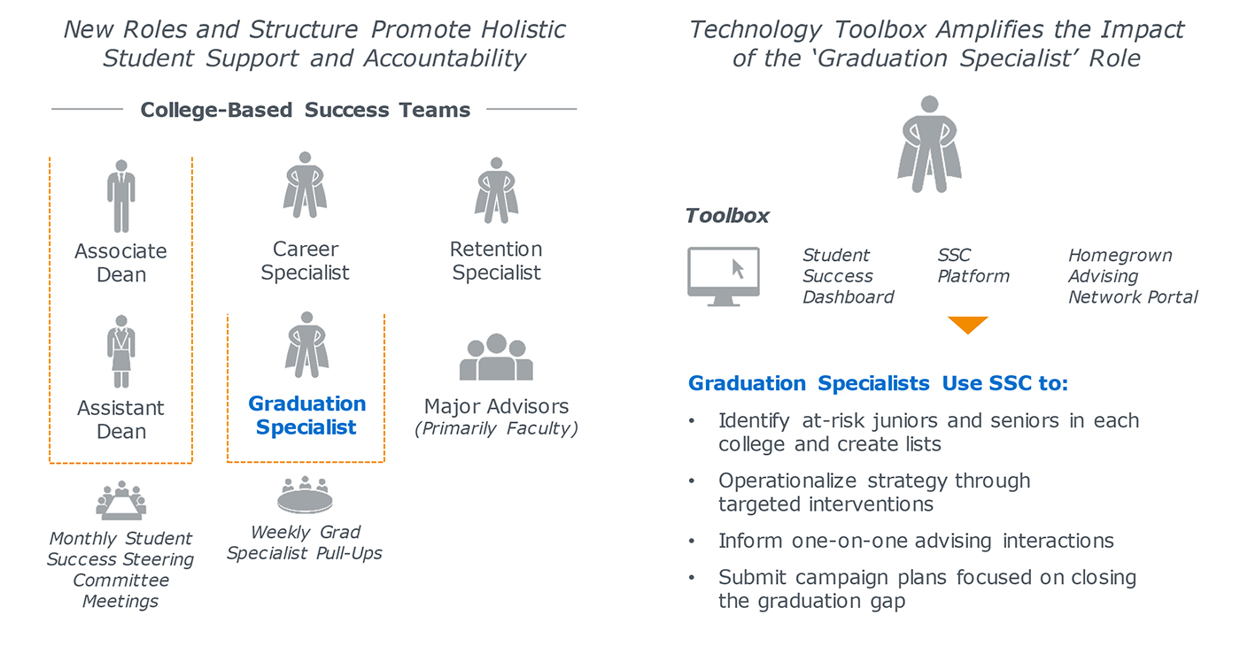

Exploring New Scalable, Tech-Enabled Advising Practices
Piloted Mandatory Advising for Juniors in Fall 2014
